Data Story Telling

Data Visualization

Mohamud A Mohamud

26/06/2024

Contents

Policies and Procedures ………………………………………………………………………………….2

Set a password to protect the workbook …………………………………………………………….4

Highlight column C and change the data to display in British Pound symbol ..………….4

Turn the GDP sheet into a table ………………………………………………………………………..5

Filter the table to display only the information for 2019 ………………………………………..6

Create chart displaying the following data, Rank, Country and GDP- per capita(PPP)..6

Using creative skills edit the chart …………………………………………………………………….7

Move the chart to a new sheet tab and label with a suitable name …………………………8

Create a sort for the top 20 highest ranking countries ………………………………………….8

Create a new Bar chart displaying the 20 highest ranking countries from sort ………….9

Colour the background by highlighting the area underneath the table …………………….9

Tableau dashboard ……………………………………………………………………………………….10

# 

# Policies and Procedures

When working with data, several policies and procedures need to be adhered to ensure data integrity, security, and compliance with legal and ethical standards. Here are key policies to consider, especially when working with a dataset like "The Wealth of Nations":

1. **Data Privacy and Confidentiality**

* What it is: Ensuring that sensitive information is protected and not disclosed to unauthorized individuals.
* Why it's important: Protects individuals' personal information and prevents identity theft or misuse of data.
* How to adhere: Anonymize data where possible, use encryption, and control access to data.

1. **Data Security**

* What it is: Protecting data from unauthorized access, corruption, or theft.
* Why it's important: Maintains the integrity and availability of data and ensures that it can be trusted.
* How to adhere: Implement security measures like firewalls, anti-virus software, secure passwords, and regular backups.

1. **Data Accuracy and Integrity**

* What it is: Ensuring that data is accurate, complete, and reliable.
* Why it's important: High-quality data is crucial for making informed decisions and maintaining credibility.
* How to adhere: Validate data, perform regular audits, and correct errors promptly.

1. **Compliance with Legal and Ethical Standards**

* What it is: Adhering to laws and ethical guidelines related to data usage.
* Why it's important: Avoids legal penalties and maintains public trust.
* How to adhere: Stay informed about relevant laws (e.g., GDPR), obtain necessary consents, and follow ethical research practices.

1. **Data Usage Policies**

* What it is: Using data only for its intended purpose.
* Why it's important: Prevents misuse of data and respects the terms under which data was collected.
* How to adhere: Clearly understand and document the purpose of data collection and ensure all usage aligns with this purpose.

1. **Transparency and Accountability**

* What it is: Being open about how data is collected, used, and shared, and taking responsibility for data-related activities.
* Why it's important: Builds trust and allows for scrutiny, ensuring ethical practices.
* How to adhere: Document data sources, usage, and handling procedures, and be prepared to explain them to stakeholders.

1. **Data Retention and Disposal**

* What it is: Managing how long data is kept and how it is securely disposed of when no longer needed.
* Why it's important: Reduces risk of data breaches and ensures compliance with data retention policies.
* How to adhere: Follow organizational policies on data retention periods and use secure methods for data disposal.

**Importance for Data Analysts**

Understanding and adhering to these policies is crucial for data analysts because:

* Trust and Credibility: Ensures that their work is trusted by stakeholders and the public.
* Legal Compliance: Avoids legal issues that can arise from mishandling data.
* Data Quality: Ensures the data is reliable and valid, which is essential for accurate analysis.
* Ethical Responsibility: Upholds ethical standards in research and data analysis, contributing to the greater good.
* Professional Reputation: Protects and enhances the analyst's professional reputation by demonstrating diligence and responsibility.

By following these policies, data analysts can work responsibly and effectively with "The Wealth of Nations" data or any other dataset.

# 2- Excel

First thing I’ve done is opened the excel table and familiarised myself with the contents of the ‘Wealth of Nations’ data. There are three tabs in the table but for my excel work I will be working with the GDP (Gross domestic product) tab.



**Set a password to protect the workbook**

To set a password you click on the review ribbon at the top of the sheet and click on protect workbook in the protect section.

**Highlight column C and change the data to display in British Pound symbol**

In order to change the data so that it displays in British pounds you must first highlight the whole of column C with the title GDP- per capita(PPP) and right click anywhere in that same column, look for format cells and click on the currency format in the number section of format cells.

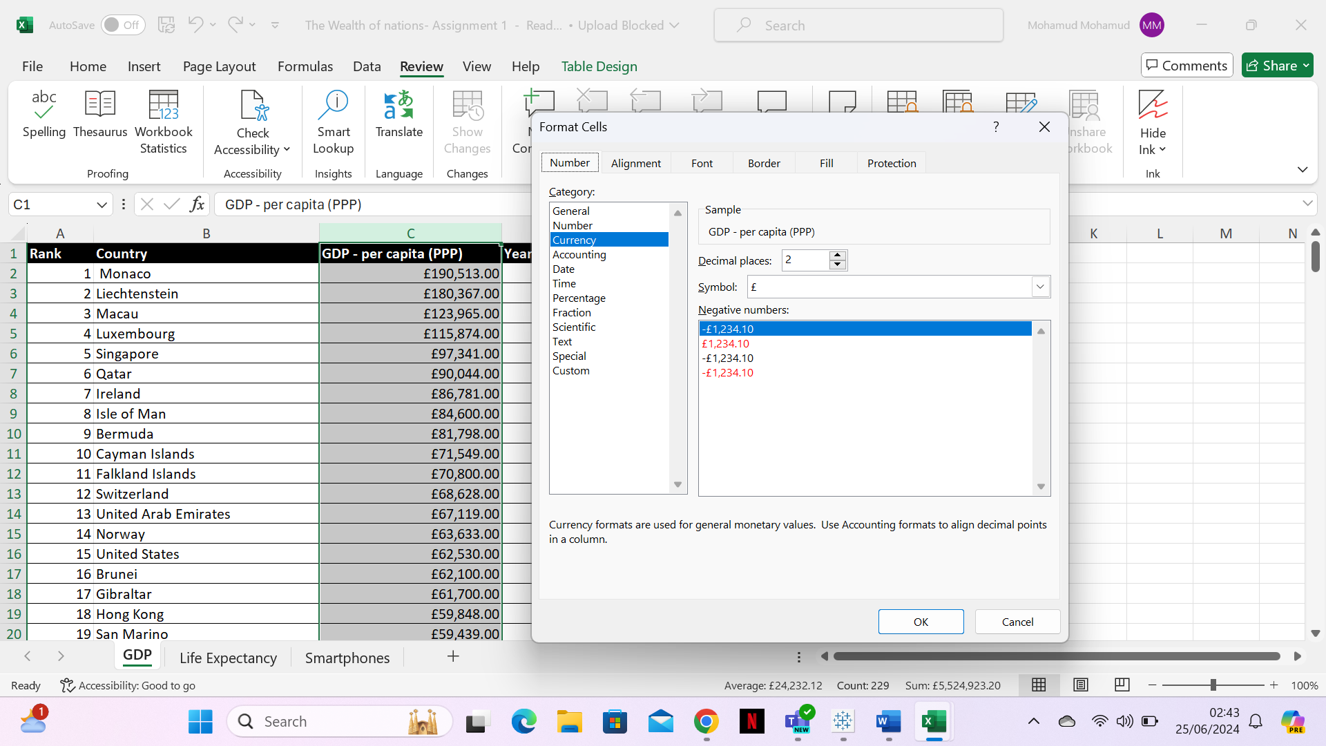

**Turn the GDP sheet into a table**

To turn the sheet into a table first you go to the insert tab on the ribbon, highlight your data and click on the table button in the tables group. A create table dialog box will appear. Ensure that the "My table has headers" checkbox is checked , then click ok. Once it’s converted into a table, another table design tab should pop up for you to customize how you like.

**Filter the table to display only the information for 2019**

In your table look for the data ribbon and click on filter which will create a drop down list for each header. In the year of information column on the table you click on the drop down list and de-select all the years except 2019. This will only display the information for 2019.

**Create a chart displaying the following data ‘Rank, Country and GDP - per capita (PPP).**

First highlight the rank, country and GDP columns. Then look for the insert ribbon and click on recommended charts to find recommendations on a suitable chart to use.

**Using creative skills to edit the chart**

**Title**

For the title you click on the chart and a plus sign should appear next to it. Click the plus sign and tick the chart title label and type in a suitable title for the graph.

**X and Y axis label**

In the same plus tab you select the axis titles and pick suitable titles for each axis.

I made the chart visually pleasing by removing the rank labels so the countries can be viewed more clearly and I also added a font colour and changed the sizes of the titles to compliment the chart and make the labels more noticeable.

**Move the chart to a new sheet tab and label with a suitable name**

You right click on the chart and click on move chart. In the pop up add you select new sheet, type a suitable sheet title and finally click ok.

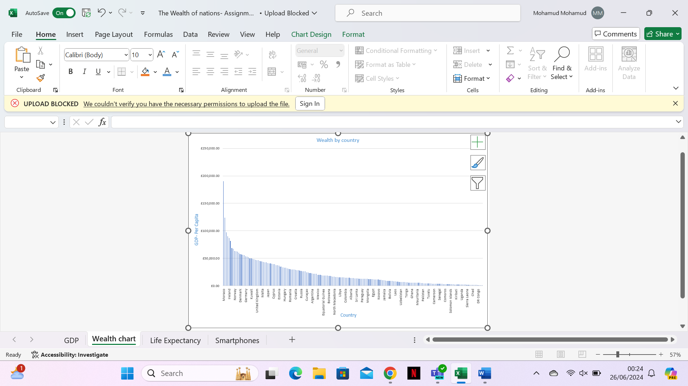

**Create a sort for the top 20 highest ranking countries**

In the rank column you click on the drop down menu and look for number filters. When you hover over the number filters you should have some more selections available and you click on top 10. A pop up should appear in which you can change it from top 10 to top 20. Once you’ve changed the 10 to 20 click ok.

**Create a new Bar chart displaying the 20 highest ranking countries from sort**

First you highlight the rank, country and GDP columns. Then you look for the insert ribbon and click on the bar chart label in charts.

**Colour the background by highlighting the area underneath the table**

First you right click on the plot area of the chart and then select format plot area. In the pop up box on the fill section you click on colour and pick whichever colour you believe suits the chart.

3- Tableau Dashboard

I’ve created a tableau dashboard for the top 20 highest ranking countries. I’ve also made sure to add suitable colours in order for the dashboard to be easily read by the client, who is colour blind. You can also find the dashboard on tableau public using this link: <https://public.tableau.com/views/Assignment1Tableau_17194971644080/Dashboard1?:language=en-US&publish=yes&:sid=&:display_count=n&:origin=viz_share_link>

